Ex:No:19
Date:

Aim:

TRIGGER

To implement trigger in MySQL.

A trigger or database trigger is a stored program executed automatically to respond to a specific event e.g., insert, update or delete occurred in a table.

Syntax-Create trigger

CREATE TRIGGER trigger_name

trigger_time trigger_event

ON table_name

FOR EACH ROW

BEGIN

statements;

END;

Program 1 :
Create a trigger in MySQL to log the changes of the STUDENT table with fields ID, Name and Email. Also create a new table named EMPLOYEES_AUDIT to keep the changes of the employee table. Create a BEFORE UPDATE trigger that is invoked before a change is made to the employees table.

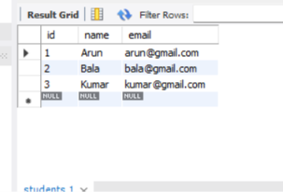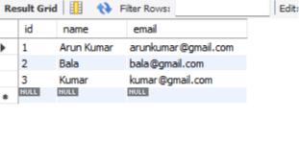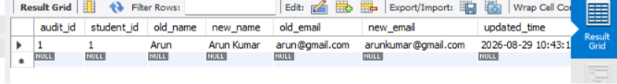
RESULT: Thus the trigger is executed successfully.

